**Exercise 1: Setting Up Junit**

**Scenario:**Need to set up JUnit in the Java project to start writing unit tests, and create a test class

**Code:  
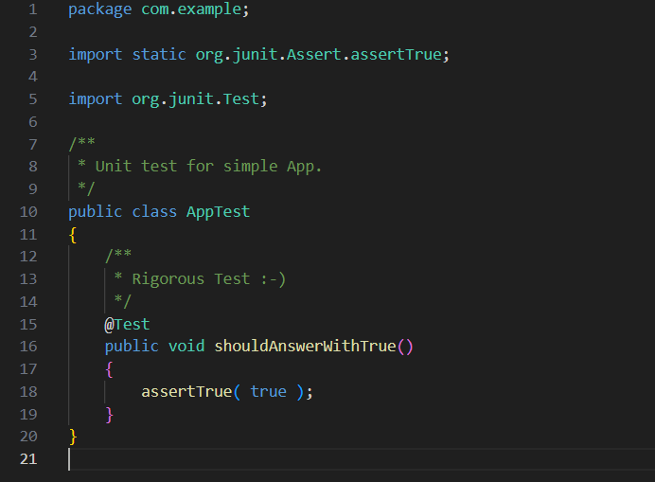**

**Output:**

